**THE ANALYSIS OF THE MOVEMENT OF WILD TIGERS IN BETWEEN PATCHES**

**1Anannya Roy Chowdhury, 2Tanya Bansal, 3Saurabh Shanu**

1Department of Business Analytics, School of Computer Science and Engineering, University Of Petroleum and Energy Studies, Dehradun 248007, Uttarakhand, India.

2Department of Virtualization, University of Petroleum and Energy Studies, Dehradun 248007, Uttarakhand, India

**Abstract**

Wherever wildlife management concerns the movement of individuals across structured habitat, its scale of operations will encompass metapopulation dynamics. It is essential to understand the dynamics of populations inhabiting fragmented environments (patches) in ecology. A number of populations exist in discrete patches of habitat due to the natural dispersal, for example, species of wild tigers. However, many populations must survive in a patchy and changing environment due to the destruction of their natural habitats such as mining activities, forest fire, etc.

Metapopulation dynamics is very helpful in wildlife management when it is concerned with the movement of individuals across the habitat patches. Determining the distributional patterns of gene flow of an endangered species metapopulation occupying a fragmented habitat is crucial for conservation planning and developing effective conservation strategies. Tigers (Panthera tigris) are globally endangered and their populations are highly scattered and exist in a few isolated metapopulation across their range.

In this paper, we use Game Theory (Hawk and Dove game model), TPSMS (Territorial Predator Scent Marking Scheme), Graph Theory and Minimal panning Tree(kruskal algorithm) concepts to model, find mobility rate and distributional patterns, with tiger (*Panthera tigristigris)* as the focal species. We define metapopulation patches to examine the dynamics of the meta-population under each area. We find that the relationships between patch characteristics such as area, connectivity and the demographic processes of migrations vary among the different patch definition methods.

1. **Introduction**

**//to be changed.**

1. **Patch Definition or Landscape Complex- The Central Indian Ghats(valley)**

The metapopulation approach provides a framework to model the population dynamics of a set of interconnected subpopulations (Hanski 1999) of the individual subdivisions of a large landscape complex. A landscape complex is a bio-geographical unit comprising contiguous ecological landscape patches (or at least minimally connected in the recent past), that have a potential for gene flow between the tiger populations (or other wildlife species) inhabiting the forests comprising the complex.

Landscape deﬁnition is pivotal to the construction of the realistic metapopulation model, because it will determine patch size and connectivity, the latter being a function of the size and distance of neighboring patches.

The prime focal landscape complex of our paper is the Central Ghats of India. The Central Highlands of [India](https://en.wikipedia.org/wiki/India) are a biogeographic region in [India](https://en.wikipedia.org/wiki/India) formed by the disjunct ranges of the [Satpura](https://en.wikipedia.org/wiki/Satpura" \o "Satpura) and [Vindhya Hills](https://en.wikipedia.org/wiki/Vindhya_Hills). It is given the term 6A within the Deccan zone in the Rodgers and Panwar (1988) classification. The zone adjoins 6D, the Central Plateau and 4B, the Gujarat Rajputana and extends across the states of [Maharashtra](https://en.wikipedia.org/wiki/Maharashtra), [Madhya Pradesh](https://en.wikipedia.org/wiki/Madhya_Pradesh), Bihar, Jharkhand,

Chhattisgarh, Odisha, Andhra Pradesh, and Rajasthan. The total area is approximately 250,000 km2 and there are 27 Protected Areas (20 Wildlife Sanctuaries and 7 National Parks) covering 4.9% of the area. There are also six [Project Tiger](https://en.wikipedia.org/wiki/Project_Tiger) Reserves in the region.

Of this, roughly 40,837km2 is under forest cover, with some of the country’s most famous tiger reserves and Protected Areas. This landscape supports 30 per cent of the world’s tiger population and 17 per cent of India’s tiger population with some of the largest contiguous forested tracks connected through wildlife corridors. Some of the tiger reserves critical from a conservation standpoint in this landscape are Kanha, Satpuda, Pench, Melghat, Tadoba and Achanakmar.

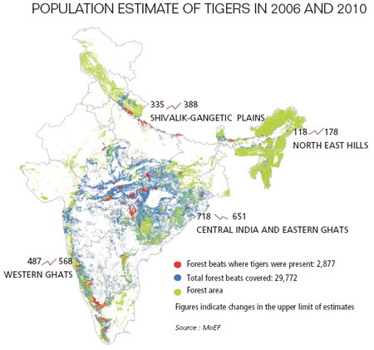

Fig. 1: A statistical representation of the forest and the tiger population in central Indian landscape.

Persistent anthropogenic impacts leading to relatively high pressure on the ecosystems owing to economic and allied developmental activities in this natural resource-rich region, even since pre-independence, colonial days continued into the present, and over a period spanning nearly two centuries, has resulted into continual degradation of forests in the landscape complex.

Despite the various environmental issues faced, the country still has a rich and varied wildlife compared to Europe. Large and charismatic mammals are important for wildlife tourism in India, and several national parks and wildlife sanctuaries cater to these needs. [Project Tiger](https://en.wikipedia.org/wiki/Project_Tiger), started in 1972, is a major effort to conserve the [tiger](https://en.wikipedia.org/wiki/Tiger) and its habitats. At the turn of the 20th century, one estimate of the tiger [population](https://en.wikipedia.org/wiki/Population) in India placed the figure at 40,000, yet an Indian tiger census conducted in 2008 revealed the existence of only 1,411 tigers. 2010 tiger census revealed that there are 1700 tigers left in India.

As per the latest tiger census (2015), there are around 2226 tigers in India. By far, there is an overall 30% increase in tiger [population](https://en.wikipedia.org/wiki/Population). Various pressures in the later part of the 20th century led to the progressive decline of [wilderness](https://en.wikipedia.org/wiki/Wilderness) resulting in the disturbance of viable tiger [habitats](https://en.wikipedia.org/wiki/Habitat).  The framework was then set up to formulate a project for tiger conservation with an [ecological](https://en.wikipedia.org/wiki/Ecology) approach. Despite the above factor which may be deemed detrimental to the health of regional biodiversity, the landscape complex, together with three Biosphere Reserves, is the largest tiger occupied area in India, and is home to the largest number of tigers in the country.

Also in this complex, various Tiger Conservation Units belonging to levels I, II and III have been identified for according priority status for conservation (Gopal et al. 2010; Jhala et al. 2008, 2011; Johnsingh and Goyal 2005). Thus, in this landscape complex of significantly high conservation value, the task of maintaining the present tiger habitats and recolonizing the ones that had reported tiger occupancy in the recent past is primarily dependent on the existence of viable tiger corridors available for individual animals to use for dispersal and travelling within the complex. Throughout the paper, we shall treat the immediate past and present tiger occupancy sites equivocally as tiger habitat patches in the landscape.

Fig. 1: A statistical representation of the tiger population in the Indian landscape complex, an excerpt from Times of India news article.

1. **Hawk and Dove Game theory**

Game theory is the mathematical model which is used to find out the payoff of the decision makers as it is the study of conflict and cooperation. There are two approaches of it- i.e. classical and evolutionary. Here the evolutionary approach is taken because it is dynamic in nature, which provides an element which is important and missing from the traditional theory.

The principle of the Hawk and Dove game is that while it is to both players’ benefit if one player yields, the other player's optimal choice depends on what his opponent is doing: if his opponent yields, the player should not, but if the opponent fails to yield, the player should. The concept of Hawk and Dove game theory is used as it gives better payoff for the quantum games by using random strategy. It uses both pareto optimality and nash equilibrium concept to maximize the payoff.

Let the Hawk and Dove game be represented by G and the pure strategies opt by the two decision makers called hawk (H) or dove (D). It is represented as:

G= {P, ∑, π}, where

‘G’ is the set of the game theory,

‘P’ is the set of players,

‘∑’ is the set of strategies applied to play a game,

‘π’ is the set of the associated playoffs.

In this, the tigers can be categorized into two types –Hawk and Dove. Hawk are aggressive in nature and always fight until it takes the ownership of the resource or gets injured , Dove show patience with some cost( time and energy) and always tries to share the available resource but fails to win against Hawk. One tactic in the game is for the tiger (acting as hawk) to signal their intentions convincingly before the game begins. For example, if the tiger were to ostentatiously disable their opponent just before the match, the opponent would be compelled to swerve.This shows that, in some circumstances, reducing one's own options can be a good strategy.

For our paper, Tigers are classified on the basis of performance as:

* When it acts as Hawk
* When it acts as Dove

The payoff matrix of the Hawk-Dove can be represented as follows:

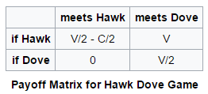

With row player being the first player p1 and the column player being the second one p2. In the above game, both the player p1 and p2 have two pure strategies each to choose from: either play *H* or play D. If both play *H,* each obtains a reward *V/2-C/2* as the payoff for showing aggressiveness. If both play *D* instead, each obtains V/2 for sharing the resources, as the payoff. If one player plays *H* while the other plays *D*, then the one playing *H* obtains a payoff of V and the one playing *D* gets a payoff 0. The game *G* is then defined by the constraint on the payoffs thus: *V> V/2> (V/2-C/2)>0.*

Thus, by using the game theory concept of Hawk and Dove we can calculate the score of the grids. So using the following payoff matrix we calculate the scores for each grid as follows:

S[i][j] = ∑∑T[i][j]*Parameter[i][j]* (payoff), {Where S: Score matrix of the grids.}

From the above discussion, it is clear that using random strategies which is a mixture of pure strategies can give better payoffs.

1. **Modelling**

For the purpose of the present work, we assume that the wild tiger habitat patches in the landscape complex constitute the vertices and the collection of connections within these patches constitute the edges, comprising the focal landscape complex as a graph. The existence of an edge between any two vertices represents some population flux between the adjacent vertices.

An occupancy matrix is constructed using the ‘identity’ function of ARCGIS algorithm to indicate the cost incurred by the tiger for passage between the habitat patches in the landscape. Analysis of the graph is done using hawk and dove game theory algorithm, graph theory and minimum spanning tree (Kruskal) algorithm, in order to identify and focus on potentially important habitat patches, their potential community structure, and the possible movement patterns and the mobility rate of the tigers in between these patches.

Correlation analysis is performed on the centrality indices to draw out interesting trends in the network.

Module 1: Setting up the grids over the focal landscape.

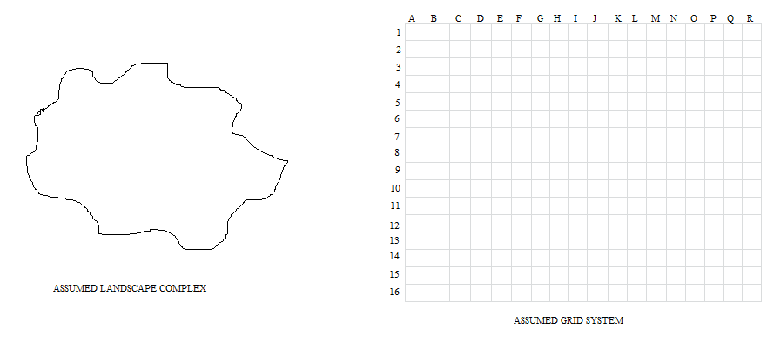

Fig 1: A diagrammatic representation of the landscape needs to be studied under the assumed grid system.

Firstly a landscape has been assumed over which the grids need to be projected as represented in Figure 1. The grid distribution system is comprehended as latitudes and longitudes. Latitudinal rows are symbolized by numbers. Longitudinal columns are symbolized by alphabets. The focal landscape (preferably the central Indian landscape region) is then divided into smaller habitat patches by setting up the grid over the landscape as represented by Figure 2.

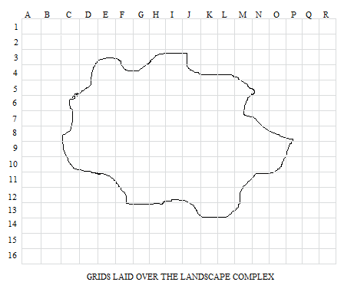

Fig.2: A diagrammatic representation of the set up landscape.

Module 2: Finding the complete and partial occupancy matrix.

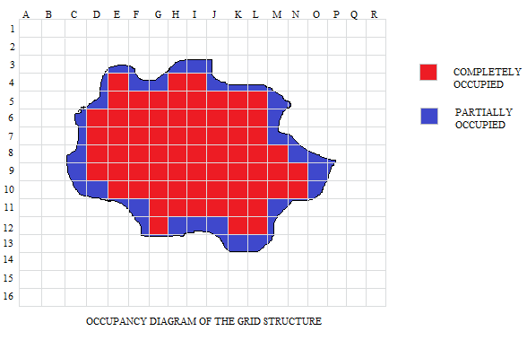

Fig 3. A diagrammatic representation of the landscape with the partial and maximum occupancy.

In Figure 3. We define the partial and complete occupancy of the landscape projected on the grids with their defined ids, if they lie inside the landscape. This has been done in order to obtain the correct membership of the various features and their contributions to calculate the score of a grid.

Module 3: Area occupancy matrix over the grid system.

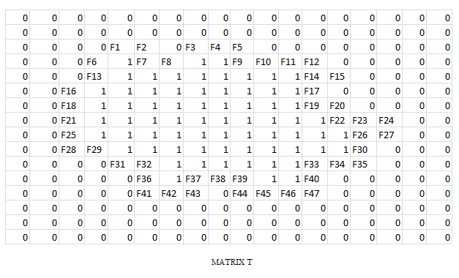

Fig. 4: A diagrammatic representation of the occupancy area of the matrix with their id.

For the section of the area which intersects between the grid system and the focal landscape complex, we calculate the fraction occupancy on the scale of one. This can be obtained using the “*identity”* function in ARCGIS.

ARCGIS “identity” predicate is a default function required by all rasters in a mosaic dataset if there is no other suitable function. It is used to define the source raster as part of the default tiling behavior of the mosaic dataset and computes a geometric intersection of the input features and identity features. The input features or portions thereof that overlap identity features will get the attributes of those identity features.

The processing is done incrementally on subdivisions of the original landscape. Grids that straddle the edges of these subdivisions (also called tiles) are split at the edge of the tile and reassembled into a single grid during the processing. The vertices introduced at these tile edges will remain in the output features. Tile boundaries can be excluded in the output matrix when being processed.

The output of the algorithm will be an id coded matrix with labelling them:

* “0” for outside landscape
* “1” for inside the landscape
* “identity” for boundary of the landscape

For this module we use the following algorithm:

Algorithm Module_3 (L, G)

//Input: 2D matrix of Grid.

2D matrix of focal Landscape

//Output: 2D matrix showing the occupancy matrix

n = no. of rows of L

m = no. of columns of L

p = no. of rows of G

q = no. of columns of G

for (i = 0, i < n, i++)

for (j = 0, j < m, i++)

for (k = 0, k < p, i++)

for (l = 0, l < q, i++)

if (L[i][j] ! = G[k][l]) then

T[p][q] = 0

Else if (L[i][j] = G[k][l]) then

T[p][q] = 1

Else

T[p][q] = identity (L[i][j], G[k][l])

Return T.

Module 4: Parameter/Decision Variables judgment for the given landscape.

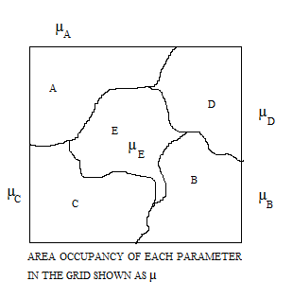

Fig. 5 A diagrammatic representation of the decision variables affecting the different areas within the landscape.

Decision variables are those parameters or the factors that elucidate the governing criteria for the persistence and the intensity of the supporting and demoting rationales of metapopulation strength for a region. The factors for each region may vary in a temporal manner and may range from the parameter brackets of habitat improvement, land acquisition, forest cover, prey base and other coordination activities.

We also check the area occupancy of each parameter in each and every grid. This is done by a linear programming model of the following constitution:

Algorithm Module_4 (T, A, B, C, D, E)

//Input: 2D matrix of Obtained through module 3.

2D matrix of parameters in the focal Landscape

//Output: 2D matrix showing the area occupancy matrix in each grid (updating existing parameters matrix)

n = no. of rows of T

m = no. of columns of T

for (i = 0, i < n, i++)

for (j = 0, j < m, i++)

if (T[i][j] = 0) then

-------------------------------------

Else

A[i][j] = identity (T, A)

B[i][j] = identity (T, B)

C[i][j] = identity (T, C)

D[i][j] = identity (T, D)

E[i][j] = identity (T, E)

Return A, B, C, D, and E.

For our sample model we have considered the 5 different parameters: A, B, C, D and E and the area occupancy in each group obtained as the membership values for each parameter as the contribution in the total score of the grid.

Module 5: Payoff Calculation using the Evolutionary game model of Hawk and Dove.

The game model we intend to use is the Hawk and Dove Evolutionary game. The contestants can be either Hawk or Dove. These are two subtypes or morphs of one species with different strategies. The Hawk first displays aggression, then escalates into a fight until it either wins or is injured (loses). The Dove first displays aggression, but if faced with major escalation runs for safety. If not faced with such escalation, the Dove attempts to share the resource.

We are using the concept of hawk and dove game theory because it gives a better payoff for the quantum games using a random strategy and maximum payoff for pure strategy. It uses both pareto optimality and nash equilibrium concept to maximize the payoff. It removes the local correlations where both the players are unaware of the fact that an entangled state has been distributed amongst them.

In our model, we need to classify the players acting as hawk or dove as these are two different types of the same species with different outlook and strategies.

Conditions of the game to be played as:

* Hawk being aggressive
* Dove trying to share the available resources.

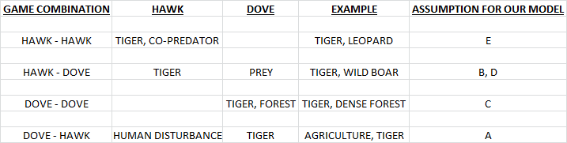

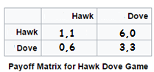

Fig. 6: A tabular representation of the hawk and dove game theory.

Algorithm Module_5 (T, A, B, C, D, E)

//Input: 2D matrix of Grid.

2D matrix of updated parameters in the focal Landscape

//Output: 2D matrix showing the score matrix of grids S

n = no. of rows of T

m = no. of columns of T

for (i = 0, i < n, i++)

for (j = 0, j < m, i++)

S[i][j] = T[i][j]*A[i][j]* (-6) + T[i][j]*B[i][j]*6 + T[i][j]*C[i][j]*3 +

T[i][j]*D[i][j]*6 + T[i][j]*E[i][j]* 1

Return S.

Module 6: Ranking of the grids and Color Coding the cluster of rankings.

The ranking of the grids can be done in various ways, based on our suitability, like:

1. On the basis of class size.
2. On the basis of Centrality measures.
3. On the basis of ground data.
4. On the basis of any pre dominant factor, etc.

Here preferably we go through the Centrality measures and out of the present 288 grids for our model we rank them based on their respective scores and then dividing it into broad 10 categories decide the color code as given in Figure 6.

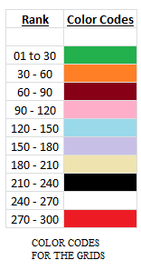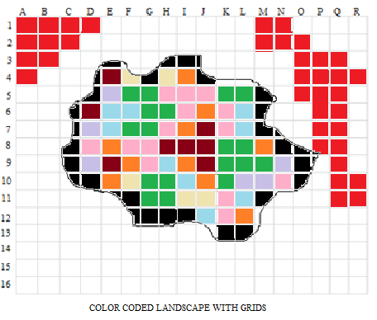

Fig. 7: A diagrammatic representation of the color coded patches of the original land scape and the rank matrix of each color.

Flood fill [algorithm](https://en.wikipedia.org/wiki/Algorithm) determines the area [connected](https://en.wikipedia.org/wiki/Glossary_of_graph_theory#Connectivity) to a given node in a multi-dimensional [array](https://en.wikipedia.org/wiki/Array_data_structure). It is used in the "bucket" fill tool to fill connected, similarly-colored areas with a different color for determining which pieces are distinguishable.  The algorithm looks for all nodes in the array that are connected to the start node by a path of the target color and changes them to the replacement color. Thereafter ranking of the grids are done on the basis of the color fill as shown in Figure 7. Based on the above color codes we run our following algorithm and then process the codes in our sample.

Algorithm Module_6 (S)

//Input: 2D matrix S

//Output: Color Coded grid system and color matrix

n = no. of rows of S

m = no. of columns of S

z = centrality index

for (i = 0, i < n, i++)

for (j = 0, j < m, i++)

t = max (S[i][j])

r = min (S[i][j])

sample = (t – r) / z

for (i = 0, i < n, i++)

for (j = 0, j < m, i++)

for (k = 0; k = t)

R[i][j] = count (sample multiplication)

for (i = 0, i < n, i++)

for (j = 0, j < m, i++)

for (k = 0; k = t)

R[i][j] = color_fill (sample multiplication)

Return R.

Module 8: Designing an Algorithm to identify habitat patches within the landscape.

The habitat patches in the focal landscape will be found out using the following algorithm:

Algorithm Module_7 (R, z, a, b)

//Input: 2D matrix R

//Output: Color Coded patches in the grid system.

n = no. of rows of R

m = no. of columns of R

z = Best ranked grid color (Dark Green for our case)

R[a][b] = position of first z

If R[a][b] = partial grid then

STOP and START NEW SEARCH FOR z

If R[a][b] = 1 then

Record = R[a][b]

Module_7 (R, z, a+1, b)

Module_7 (R, z, a, b+1)

Module_7 (R, z, a-1, b+1)

Module_7 (R, z, a+1, b-1)

Module_7 (R, z, a+1, b+1)

Module_7 (R, z, a-1, b-1)

Module_7 (R, z, a-1, b)

Module_7 (R, z, a, b-1)

Return Record.

Module 8: Connectivity optimization based on results of Module 5, Module 6 and Module 7.

Algorithm Module_8 (R, z, a, b)

//Input: 2D color coded matrix of R

//Output: Minimum weighted graph with color coded patches in R and selected path.

MST-KRUSKAL(R, z)

AV← Ø

for each vertex v ­ V[R]

do MAKE-SET(v)

sort the edges of E into non-decreasing order by weight w

for each edge (u, v) ­ E, taken in non-decreasing order by weight

do

if FIND-SET(u) ≠ FIND-SET(v)

then AV← AV­ {(u, v)}

UNION(u, v)

Return AV

1. **Conclusion**

The present work has been developed with objectives to (i) predict the distributional patterns in multispecies communities using TPSMS (Territorial Predator Scent Marking Scheme), Game Theory and Graph Theory and (ii) predict the mobility rate of the meta-population individuals using suitability matrix calculation using game theory and graph theory.

In this paper we have used the concept of hawk and dove game theory to firstly identify the important habitat patches that constitute majorly to the population flux, i.e., migration. Then we use the concept of ranking and color coding by the 8-connected seed or flood fill method to fill the grids with their respective color code by the help of the scores calculated on the basis of the payoff from the hawk and dove game model. Next, we apply Kruskal’s algorithm to obtain a minimum spanning tree that could serve as a model framework for a real-world tiger corridor designing in the Central India – Eastern Ghats landscape complex.

Most criticisms of the metapopulation concept (e.g. Dennis et al. 2003) arise from shortcomings of these more restrictive definitions (Baguette & Mennechez 2004). Over the past decade, the trend in metapopulation concepts has moved from abstract models toward real-world applications. Within these limits, the definition encompasses all levels of variation between populations in colonization rates (including the extreme of ‘source–sink’ systems) and in extinction rates (including synchronous extinctions). We emphasize that a metapopulation is a dynamic system of linked populations, as opposed to simply a patchy habitat, and many of its demographic processes are visible only through the filter of models.

1. **References**
2. Caswell, H. & Cohen, J. E. Disturbance, interspeci®c interaction and diversity in metapopulations. Biol. J. Linn. Soc. 42, 193±218 (1991).
3. Gopal, R., Qureshi, Q., Bhardwaj, M., Singh, R. K. J., Jhala, Y. V., 2010. Evaluating the status of the endangered tiger *Panthera tigris* and its prey in Panna Tiger Reserve, Madhya Pradesh, India. Oryx**44**: 383 – 398.
4. Hanski, I., 1998. Metapopulation dynamics*.* Nature**396**: 41 – 49.
5. Hanski, I., Gilpin, M., 1991. Metapopulation dynamics – brief-history and conceptual domain. Biol. Journal of the Linnean Society**42**: 3 – 16.
6. Hanski, I., Ovaskainen, O., 2000. The metapopulation capacity of a fragmented landscape. Nature **404**: 755 – 758.
7. Jhala, Y. V., Gopal, R., Qureshi, Q., (eds.) 2008. Status of Tigers, Co-predators and Prey in India. National Tiger Conservation Authority, Govt. of India, New Delhi, and Wildlife Institute of India, Dehradun. TR08/001 pp-151.
8. McGarigal K and Cushman SA (2002) Comparative evaluation of experimental approaches to the study of habitat fragmentation effects. Ecological Applications 12: 335–345.
9. Nagendra H, Pareeth S and Ghate R (2006) People within parks: Forest villages and fragmentation in the Tadoba-Andhari Tiger Reserve, India. Applied Geography 26(2): 96-112.
10. Pickett STA and White PS (1985) Patch Dynamics: a synthesis. In STA Pickett and PS White (eds) The Ecology of natural disturbance and patch dynamics. New York: Academic Press: 371-384.
11. Reiss J, Bridlel JR, Montoya JM and Woodward G (2007). Emergig horizons in biodiversity and ecosystem functioning research. Trends in Ecology and Evolution 24: 505-514
12. Roy PS, Joshi PK, Singh S, Agrawal S, Yadav D and Jeganathan C (2006) Biome mapping in India using vegetation type map derived using temporal satellite data and environmental parameters. Ecological Modeling 197(1-2): 148-158.
13. Shanu, S., Iddiculla, J., Bhattacharya, S., Qureshi, Q., Jhala, Y. V., 2016. A GRAPH THEORETIC APPROACH FOR MODELLING TIGER CORRIDOR NETWORK IN CENTRAL INDIA-EASTERN GHATS LANDSCAPECOMPLEX, INDIA.arxiv:2-11.
14. Turner MG (2005) Landscape Ecology: What Is the State of the Science? Annual Review of Ecology, Evolution, and Systematics 36: 319-344.
15. Turner MG, Romme WH, Gardner RH, O’Neill RV and Kratz TK (1993) A revised concept of landscape equilibrium: disturbance and stability on scaled landscapes. Landscape Ecology 8: 213–227.
16. Taylor, P. D., Fahrig, L., With, K. A., 2006. Landscape connectivity: a return to the basics. In: Connectivity conservation*,* Crooks, K.R. & Sanjayan, M. (eds.), pp.29 – 43, Cambridge University Press, Cambridge.
17. Wikramanayake E, McKnight M, Dinerstein E, Joshi A, Gurung B, Smith D (2004) Designing a conservation landscape for tiger in human-dominated environments. Conservation Biol. **18**(3): 839 – 844.